**TSP Art**

**Course Instructor:** Prof. *Dr. Gabriel Robins*

**Author(s):** *Tamal Saha, Hamid Bagheri*

(ts4rq, hb2j)@virginia.edu

12/1/2009

# Abstract

The traveling salesman problem (TSP) is a well-known NP-complete problem. It has appeared in diverse field of human knowledge. Different heuristics have been developed to generate approximate solutions for TSP. In this project, we are using 3 different heuristics for TSP to implement a half toning algorithm.

# Approach

In this project, we have taken the following steps to implement a half toning algorithm.

Given any input image,

* If the image is a color image, convert it into a black & white image.
* Now we generate the “cities”/vertices of a complete graph on which TSP algorithm will be applied. We distribute cities with a density that locally approximates the darkness of a source image.
* Now we run nearest neighbor, greedy and 2-opt heuristics for TSP on the “cities”. This produces a single closed path that resembles the original image.

The following diagram presents the steps takes.

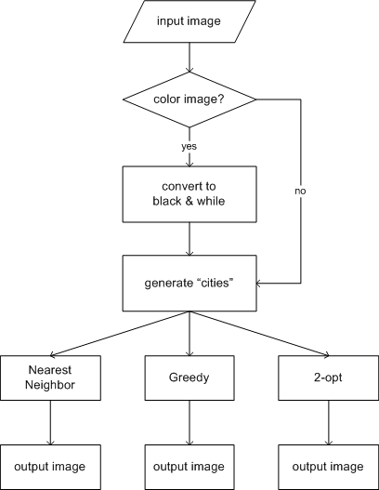

Fig 1: TSP Art steps

# Nearest Neighbor algorithm

The nearest neighbor (NN) algorithm chooses the nearest unvisited city as the next destination. Pseudo code

1. Select an arbitrary vertex as current vertex.
2. Find out the shortest edge connecting current vertex and an unvisited vertex V.
3. Set current vertex to V.
4. Mark V as visited.
5. If all the vertices in domain are visited, then terminate; otherwise, go to step 2.

The sequence of the visited vertices is the output of the algorithm.

## Time complexity:

O(n2), where n = number of cities

# Greedy Algorithm

The Greedy heuristic gradually constructs a tour by repeatedly selecting a new shortest edge and adding it to the tour as long as it doesn’t create a cycle with less than N edges.

## Pseudo code:

1. Sort all edges.
2. Select the shortest edge and add it to our tour if it doesn’t violate any of the above constraints.
3. Do we have N edges in our tour? If no, repeat step 2.

## Time complexity:

O(n2log2(n)), where n = number of cities

# 2-opt algorithm

The 2-Opt algorithm takes the output tour from either NN or Greedy algorithms as an input and convert it to a shorter one. Each 2-Opt step consists of eliminating two edges and reconnecting the two resulting paths in a different way in order to obtain a new shorter tour. It is important to note that there is just one way to reconnect the two resulting path from eliminating two edges. Checking whether an improving 2-Opt step exists takes *O(n2)* time since we need to consider all pairs of tour edges.

|  |  |
| --- | --- |
| Fig 2: input color image | Fig 3: converted black & white image |

|  |  |
| --- | --- |
| Fig 4: cities for NN alg | Fig 5: output of NN alg |
| E:\My Dropbox\Fall 2009\Theory\Theory Term Project\Project\Greedy.PNG  Fig6: output for Greedy alg | Fig 7: output for 2-opt alg |

# References:

1. <http://en.wikipedia.org/wiki/Travelling_salesman_problem>
2. <http://en.wikipedia.org/wiki/Nearest_neighbour_algorithm>
3. “Heuristics for the traveling salesman problem,” Nilsson, C. in the journal of Theoretical Computer Science Reports, Linkoping University
4. “Improving Solutions,” The Traveling Salesman, Springer Berlin / Heidelberg, vol. Volume 840/1994, 1995, pp. 413-470.